YetiBorg Qualification Challenge
Friday 22-3 2019
09.15 – 10.45
During the YetiBorg Qualification Challenge one Yetiborg will be placed on the track just before the blue line with its camera headed in the direction of the blue arrow (See Figure 1.). After a start signal is given one remote command is allowed, after which the YetiBorg should automatically complete one full round in the direction of the blue arrow and staying within the inner single orange line and the outer single white line.
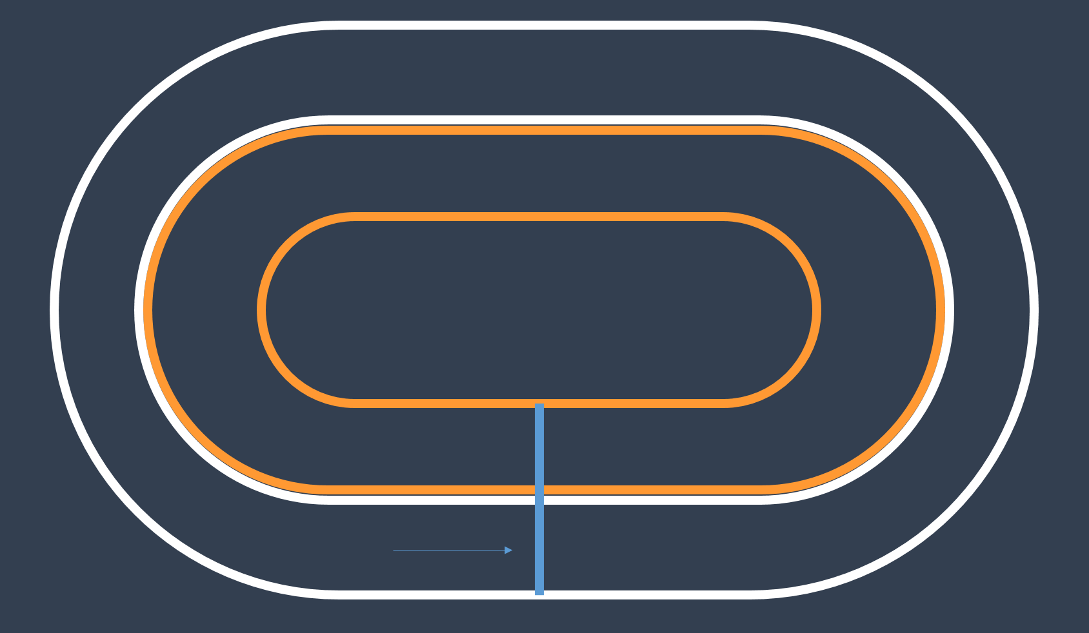
Figure 1. An example of the YetiBorg Racetrack. The YetiBorg should stay within the inner orange line and the outer white line, and should complete one full round in the direction of the blue arrow.

Some characteristics of the track:
- The lines are 3 cm wide and are made of the same materials as the example strips in the YetiBorg Racing box. They will not be completely smooth.
- The background color will be dark grey to dark blue. If other surfaces will have to be used this will be announced.
- The blue Start-/Finish-Line can be less than 3cm wide.
- The width of the track can vary from 50 cm to 80 cm.
- The length of the bounding box of the track can vary from 1.5 m to 4 m.
- During the Qualification Challenge the shape of the track will be close to an oval, during the race it can have a more random form.

